Assigned Task:

Search Engine Friendly Vehicle URLs
Include selected vehicle qualifiers in the URL structure to allow for dynamic search-engine friendly landing pages for site-wide vehicles and vehicle-specific categories, such as:
- https://realtruck.com/v/ford/
- https://realtruck.com/v/ford/f150/
- https://realtruck.com/c/exterior-accessories/bumpers/v/ford/f150/
- https://realtruck.com/c/exterior-accessories/bumpers/v/ford/f150/2022/

My Comment:
The user selections like categories, brands, prices, etc. are now shown as query params for the Gomers Inc. as shown below:
https://zoon.mybigcommerce.com/search/?category/fuel-system/category/fuel-system%3Efuel-injector-lines/brand/Dipaco/prices/50-100,100-250/
Convermax is also doing the same for Gomers Inc.

Assigned Task:

Store/Display Vehicle info in Cart and Checkout
Carry selected vehicle and any additional vehicle attributes that were selected when a specific product was added to the cart through to display in cart and checkout.

My Comment:
To achieve this:
- In Shopify
  - No need to create modifier options like in BigCommerce, we just need to pass the selected vehicle as line-item property
- In BigCommerce
  - We need to create one modifier option named “Vehicle” for each product in the store
  - For this Dev Site, I have created this for one product just for demo
  - We can programmatically create this modifier option for all products ( if required in the real implementation)
  - Link of the product for which this modifier is created:
    - https://zoon.mybigcommerce.com/bully-dog-40420-platinum-gt-diesel-tuner-40420/
    - For this product, the selected vehicle is carried on cart and checkout pages
    - I think this feature is unavailable in the current Gomers’ Website.

This demo product: https://zoon.mybigcommerce.com/bully-dog-40420-platinum-gt-diesel-tuner-40420/

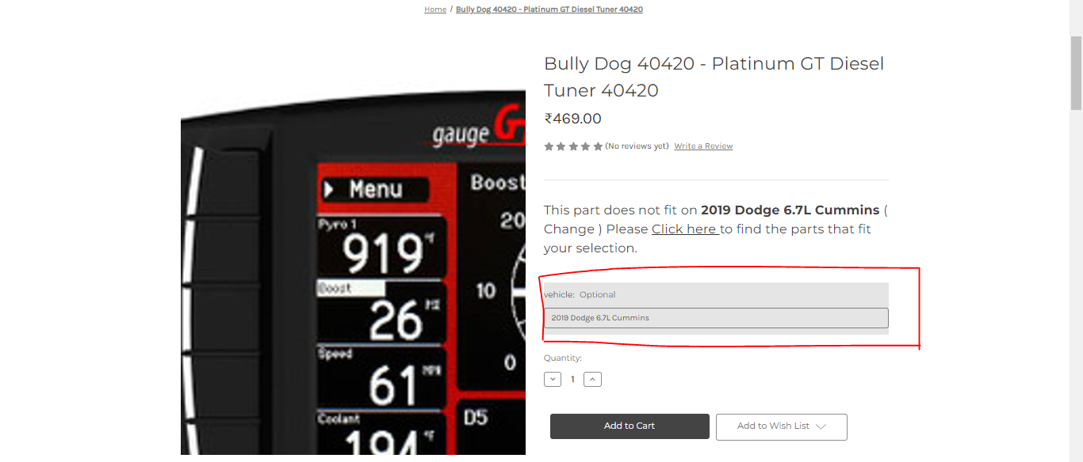

This Product In Cart Page

This Product in Checkout page
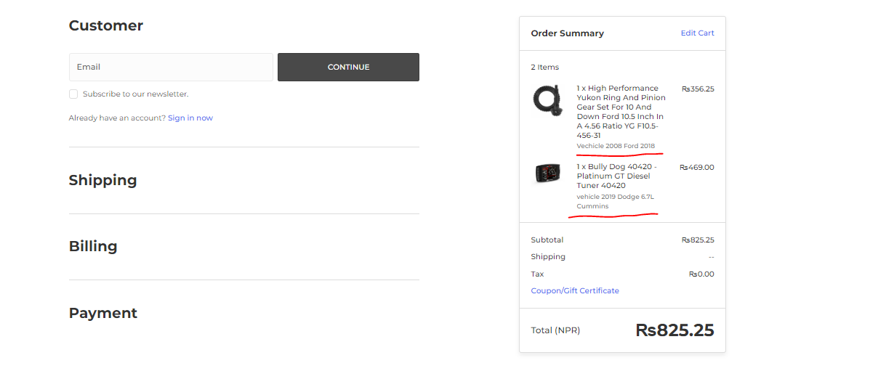

Task Assigned
Document how the app utilizes BigCommerce data and any 3rd party database utilities and what 3rd party database requirements are needed.
Answer:
At first all data related to the Product Catalog is fetched. This includes all the products, categories, and brands.
Then the fitment data is extracted from the above fetched data. This fitment data along with categories and brands are saved in the database.
To sync the database we created and the products in the BigCommerce store, we have planned to schedule API call once in a day and fetch only the products that are new or have been modified since the last database updated time (or since yesterday). This fetched data is updated correspondingly in the database.
We are currently using MYSQL as the database and PHP as the programming language.

