Assigned Task:

Search Engine Friendly Vehicle URLs
Include selected vehicle qualifiers in the URL structure to allow for dynamic search-engine friendly landing pages for site-wide vehicles and vehicle-specific categories, such as:
- https://realtruck.com/v/ford/
- https://realtruck.com/v/ford/f150/
- https://realtruck.com/c/exterior-accessories/bumpers/v/ford/f150/
- https://realtruck.com/c/exterior-accessories/bumpers/v/ford/f150/2022/

My Comment:
The user selections like categories, brands, prices, etc. are now shown as query params for the Gomers Inc. as shown below:
https://zoon.mybigcommerce.com/search/?category/fuel-system/category/fuel-system%3Efuel-injector-lines/brand/Dipaco/prices/50-100,100-250/
Convermax is also doing the same for Gomers Inc.

Assigned Task:

Store/Display Vehicle info in Cart and Checkout
Carry selected vehicle and any additional vehicle attributes that were selected when a specific product was added to the cart through to display in cart and checkout.

My Comment:
To achieve this:
- In Shopify
  - No need to create modifier options like in BigCommerce, we just need to pass the selected vehicle as line-item property
- In BigCommerce
  - We need to create one modifier option named “Vehicle” for each product in the store
  - For this Dev Site, I have created this for one product just for demo
  - We can programmatically create this modifier option for all products ( if required in the real implementation)
  - Link of the product for which this modifier is created:
    - https://zoon.mybigcommerce.com/bully-dog-40420-platinum-gt-diesel-tuner-40420/
    - For this product, the selected vehicle is carried on cart and checkout pages
    - I think this feature is unavailable in the current Gomers’ Website.

This demo product: https://zoon.mybigcommerce.com/bully-dog-40420-platinum-gt-diesel-tuner-40420/

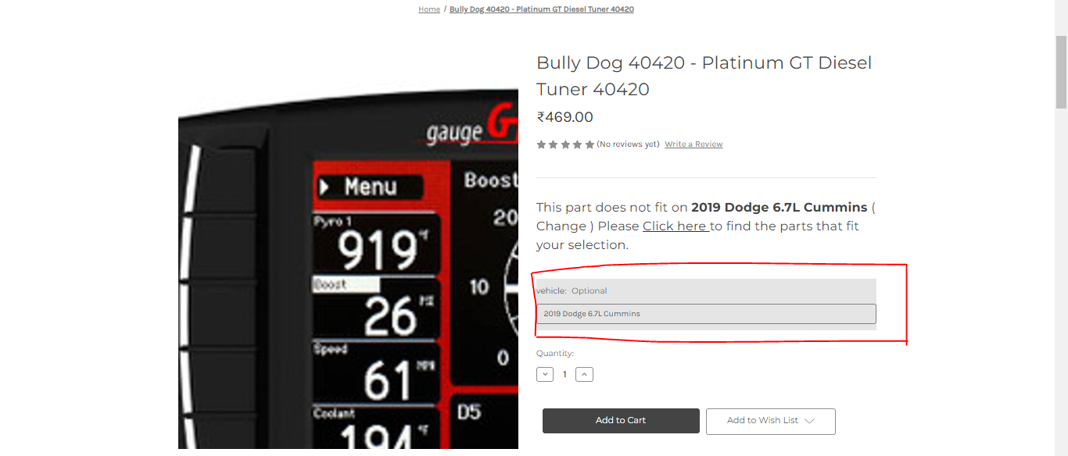

This Product In Cart Page

This Product in Checkout page
